

Locating places on the earth -II

Time calculation

<https://youtu.be/LR4hQ27UTBE?feature=shared>

Ppt

<https://www.slideshare.net/slideshow/6th-std-social-science-geography-ch-2-latitudes-and-longitudes/236888115>

I Vocabulary

Longitude

Latitude

Prime meridian

Greenwich mean time

Parallel

Meridians

Temperate zone

Torrid zone

Frigid zone

Equator

Indian standard time

II KWL

III Concept Map

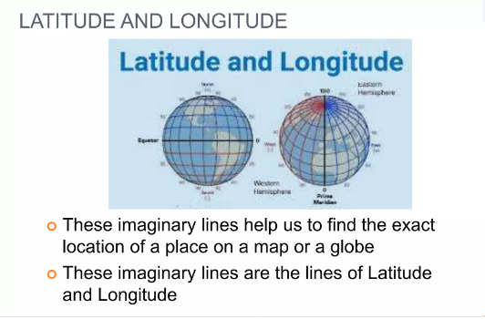

IV QUESTION ANSWER

1.Define Prime Meridian and parallels?

Lines of latitude are often referred to as parallels. Meridians of Longitude : The meridians of longitude refer to the angular distance, in degrees, minutes, and seconds, of a point east or west of the Prime (Greenwich) Meridian. Lines of longitude are often referred to as meridians.

2.Difference between Longitude and Latitude

|  |  |
| --- | --- |
| **Latitude** | **Longitude** |
| 1. It divides the Earth horizontally into the Northern and Southern Hemispheres. | It divides the Earth vertically into the Eastern and Western Hemispheres. |
| 2. The imaginary lines of latitude are usually known as parallels of latitude. | The imaginary lines of longitude are usually known as meridians of longitude. |
| 3. Latitudinal lines are parallel to each other; they reduce in size as they move towards the poles. | Longitudinal lines are of the same length; they all cut the Earth into two equal halves. |

3.Describe major heat zones of the Earth.

1. Torrid Zone:

* Torrid means hot.
* This zone receives the maximum amount of heat throughout the year, because the rays of the Sun fall vertically on this zone.
* This zone is located between the Tropic of Cancer to Tropic of capricorn

2. Temperate Zone:

* The temperate zones lie in both the hemispheres.
* North temperate zone lies in the northern hemisphere between the Tropic of Cancer and the Arctic Circle.
* South temperate zone lies in the southern hemisphere between the Tropic of Capricorn and the Antarctic Circle.
* These zones are neither too hot nor too cold.

3. Frigid Zone:

* Frigid means cold.
* Beyond the Arctic Circle and Antarctic Circle temperatures are very low and the climate is very cold.
* This is due to the extreme slanting of the Sun’s rays.
* The North Frigid Zone lies between the Arctic Circle (661/2° N) and Antarctic Circle (661/2°S)

4. How do longitudes help us in calculating time?  
Answer:  
Longitude and Time.

* Longitudes help us to calculate time.
* Time is measured by the movement of the Earth.
* The Earth moves on its axis from West to East. It is called rotation.

It takes 24 hours for the earth to complete one rotation:

* This means in 24 hours the Earth completes 360°.
* Hence, it takes about 4 minutes for crossing one degree of longitude (or it takes one hour in crossing 15 degrees of longitude)
* Accordingly, the Earth has been divided into 24 time zones of one hour each.
* This means each place has a different time of Sunrise and Sunset.

5.Draw the heat zone of earth with its name and degrees.

